Mycological Madness

DESIGN DOCUMENT

By Tristan, Alex, Kyle, Sam, & Paddy for the 2024 Pirate Software Game Jam

**Introduction** **2**

Game Summary 2

Inspiration 2

Player Experience 2

Platform 3

Development Software 3

Genre 3

Target Audience 3

**Concept** **3**

Gameplay overview 3

Theme Interpretation (Sacrifice Is Strength) 4

Primary Mechanics 4

Secondary Mechanics 5

**Art** **6**

Theme Interpretation 6

Design 6

**Audio** **7**

Music 7

Sound Effects 7

**Game Experience** **7**

UI 7

Controls 7

**Development Timeline** **8**

## Introduction

### Game Summary Pitch

Twin stick shooter about a botanist whose plants develop sentience and attack them, the player must spread fire to survive and stop the spread of the plants.

### Inspiration

### **Vampire Survivors**

"Vampire Survivors" is an indie roguelike video game characterized by its simplicity and addictive gameplay. In this game, players control a character who automatically attacks waves of monsters. As players progress, they can pick up experience points and power-ups to enhance their abilities and weapons. The game is known for its increasingly intense and chaotic levels, with a focus on survival against hordes of supernatural enemies. Its pixel-art style and straightforward mechanics have contributed to its popularity, making it a unique and engaging experience for players.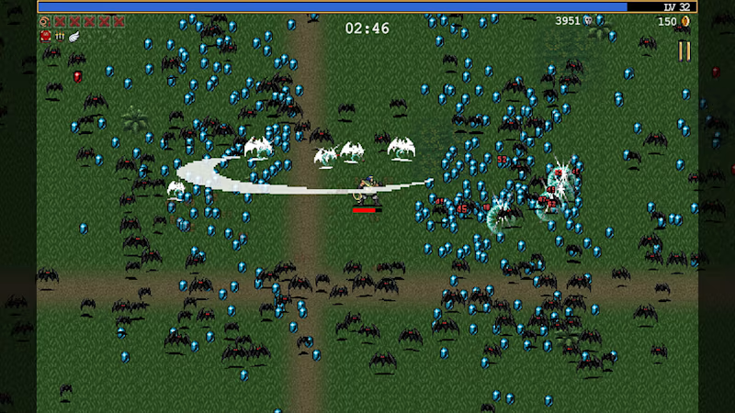

**20 Minutes Till Dawn**

"20 Minutes Till Dawn" is a roguelike shoot 'em up game featuring fast-paced, survival-based gameplay. Players choose a character and fight against relentless hordes of enemies for a duration of 20 minutes. Throughout the game, players can upgrade their character and weapons by choosing from a variety of skills and power-ups. The game's challenge lies in surviving the increasingly difficult waves of enemies within the set time limit. Its pixel-art graphics and engaging mechanics make it an addictive and exciting experience, appealing to fans of action and survival games.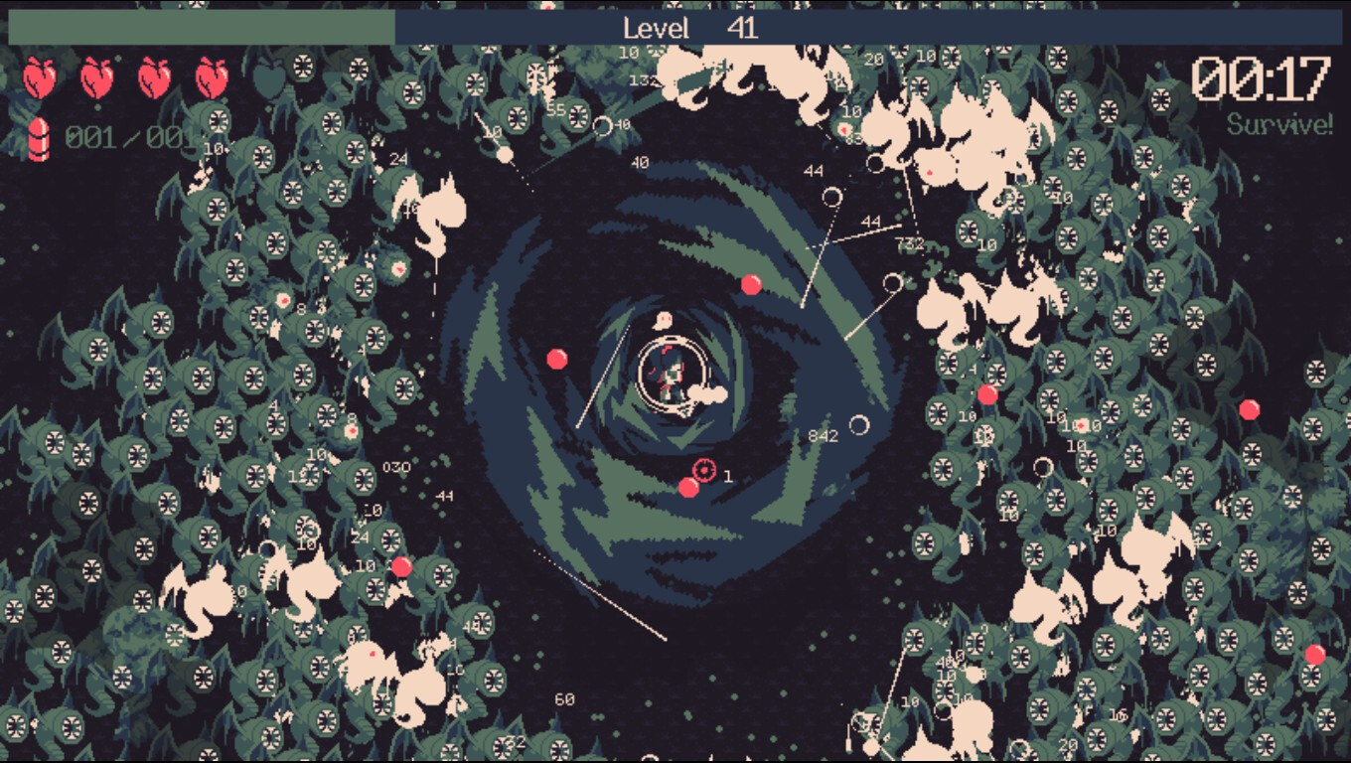

### Player Experience

At the site of their crash landing on an unfamiliar world, the player tries to survive being overwhelmed by a horde of sentient mushrooms by finding gaps in the encirclement and using their trusty flamethrower to clear a path forward. The player must be careful not to burn all of the oxygen producing plants that are scattered around the crash site or they will run out of fuel for their weapon and themselves.

### Platform

The game is developed to be released on Windows PC

### Development Software

* Godot version 4.2.1
* Photoshop for graphics and UI
* Ableton Live 11

### Genre

Singleplayer, Twin Stick Shooter, 2D, Survival

### Target Audience

Botanists, mushroom haters, or anyone who wants to watch the world burn.

## Concept

### Gameplay overview

The player controls a single human possessing a flamethrower and a limited supply of oxygen, which is used as fuel for themselves and their weapon. They are surrounded by a horde of aggressive mushrooms which are constantly being grown by other, smarter mushrooms. The flamethrower must be used generously to burn away nearby enemies, but not too generously or it might burn the only source of oxygen as well. The player primarily focuses on staying alive and trying to hunt down the source of the mycological menace. They may end up asking themselves if they should let the mushrooms have this world or cleanse it with fire?

### Theme Interpretation (It’s Spreading)

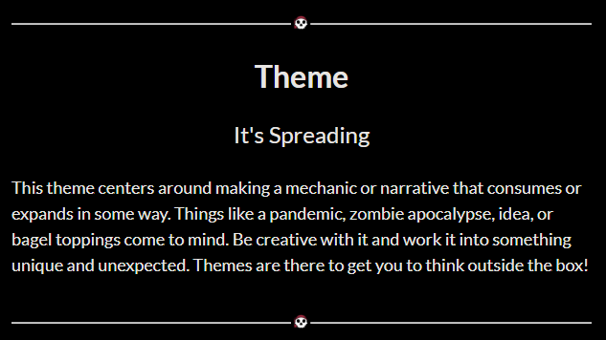

**‘Spreading’ interpretation - The game involves competing elements that are spreading in different ways. The adversary is a sentient collective of mushrooms that spread through spores while the player utilizes fire which spreads by consuming any flammable material it touches.**

By having terrain interact with the propagation of enemy species as well as fuel the availability of resources for the player, competition for growth and denial of the ability to do so make spreading not only a goal but a point of contention for both sides. Burning everything down however will deprive the player of oxygen, making rampant uncontrolled propagation of both elements undesirable to the player.*The player must control the spread of both their adversary as well as themselves in order to survive.*

### Primary Mechanics

| **Mechanic** | **Animated Mockup**  ***(Art not necessarily final)*** |
| --- | --- |
| **Flamethrower** a  An effective but dangerous weapon that the player uses to keep the mushroom horde at bay. When used, it will light nearby mushrooms and tiles on fire. These flames will spread to nearby tiles but are held in check by the available oxygen and probability of propagation. |  |
| **Oxygen** a  The player needs oxygen to stay alive but it is also consumed by the flames they create. It is produced only by stationary plants that act as resource nodes. |  |
| **Growth Terrain** a  Aside from the general horde, special enemy types will instead focus on converting terrain causing more enemies to spawn rather than attacking the player directly. This terrain will have a probability function based on how much has been converted in a local area, making these spreaders high value targets for the player. |  |
| **Spore Explosion** a  Mushrooms function the same as the basic plant enemy while alive, however upon death they release their spores infecting surrounding terrain and damaging the player. |  |
| **Machete**  This melee weapon provides an alternative option to using the flamethrower for getting rid of mushrooms. Its limited reach means it will only be especially useful for fighting while too close to an oxygen plant which the player wants to avoid catching fire. |  |
| **Leafblower**  A name for the flamethrower when it is used without any ignition. This blast of air can be used to push enemies away and put out undesirable fires. |  |

## Art

### Theme Interpretation

A contrasting color palette was chosen for these two elements both to visually distinguish them easier for the player, but also to directly communicate competition for space and resources. Additionally, non-typical colors were chosen for both the plants and the player to contribute to the alien nature of the setting and plants themselves.

### Design

The palette is limited to violets and oranges for contrast. Important entities such as the player, the Oxygen Plant, and the Spreader will utilize orange in their palette so that they stand out, while Grunts will be composed entirely of hues in the violet range as there will be far more of them on screen. Fire will utilize the brightest of orange hues and ground tiles will utilize the deepest blue of violet hues. This should allow for a good level of contrast between background and foreground elements while keeping across the screen space.

## Audio

### Music

For combat, the music will create an aggressive tone, using heavy instrumentation (drums, distorted guitar, synthesizers). For non-combat, an otherworldly environment will be evoked with non-diatonic harmony.

### Sound Effects

Sound effects will primarily be in a low-bit-rate style. Many sounds will be created using the human voice, augmented with effects.

## Game Experience

### UI

On top of the rigid pixel art constituting the rest of the art, a more smooth, higher definition style will be incorporated in the UI. Utilizing many shades of white and black allowed in the art restriction, anti-aliasing is used to further emphasize the UI.

### Controls

**Mouse & Keyboard**

Arrow keys / WASD, Spacebar, LMB, RMB, Cursor   
**Gamepad**

Dpad, Triggers, Left button, A